Nama : Hastyana R

NIM : L200170172

Kelas : G

_____________________________________________________________________________________

1.Data

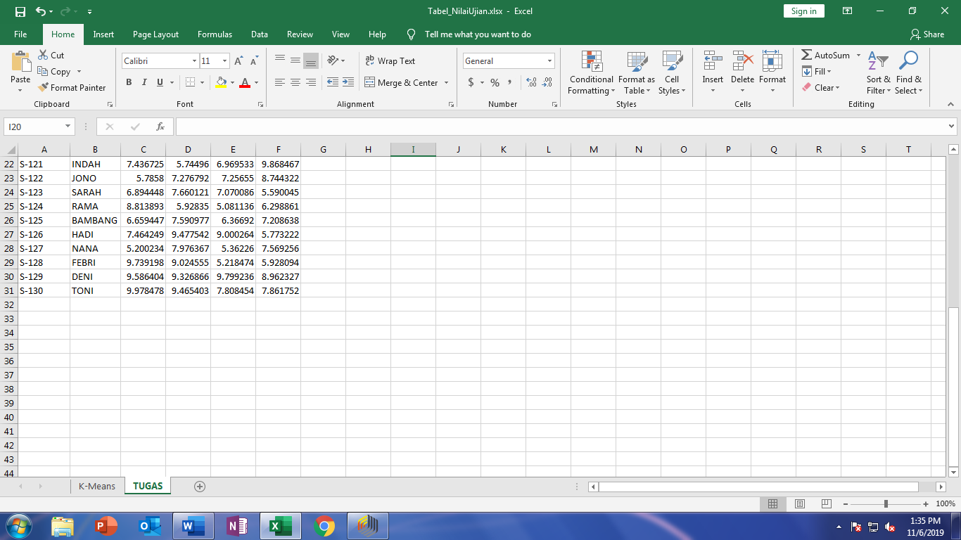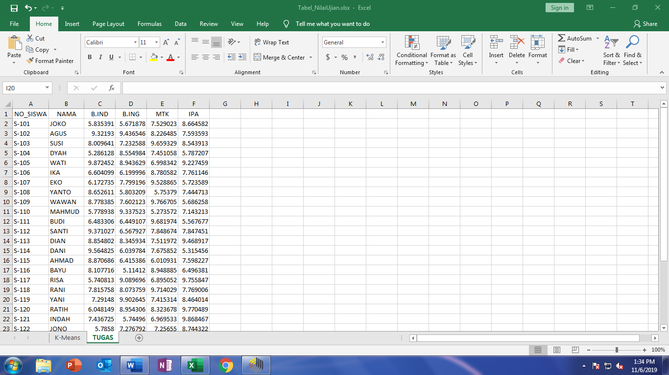

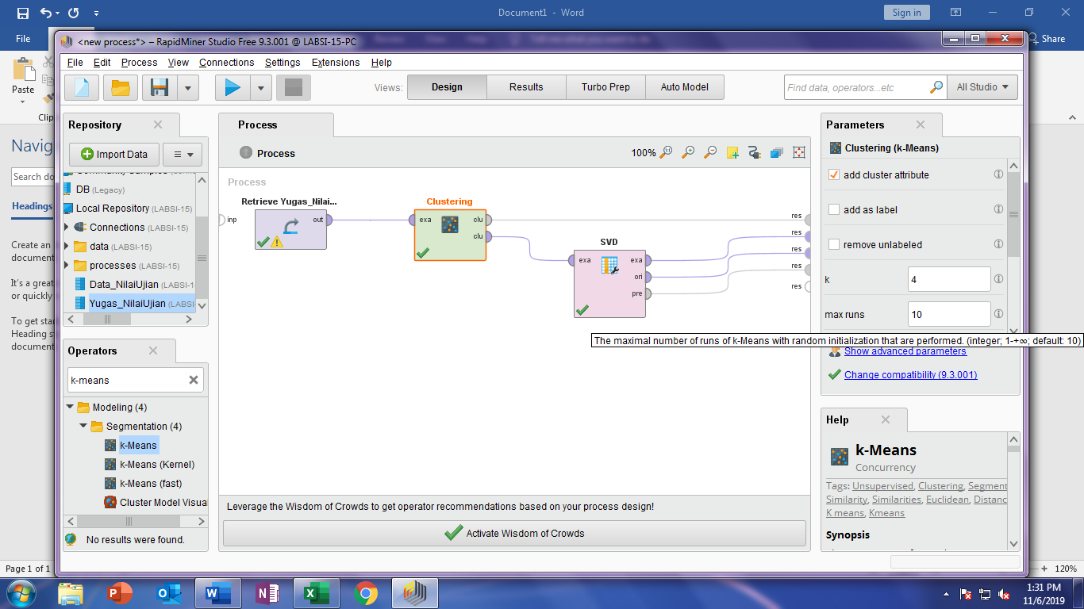

2. Kegiatan seperti latihan

1. SVD
2. Nilai eigenvalue

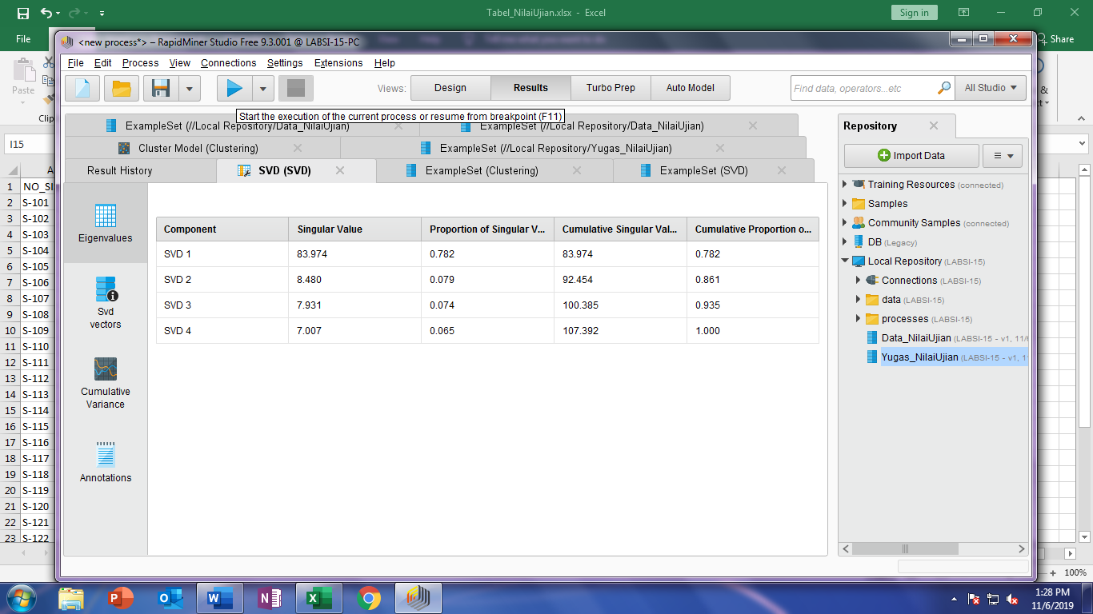

1. Nilai SVD vector

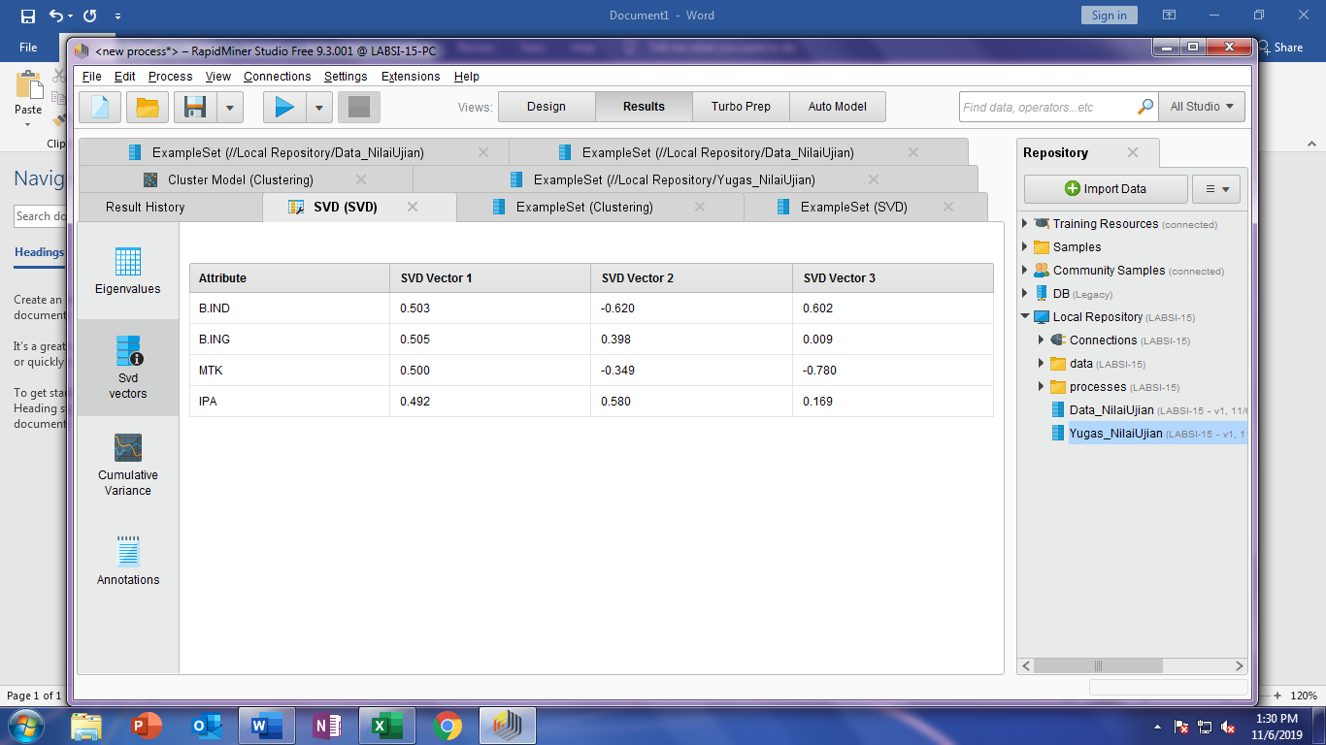

1. Nilai Cumulative variance

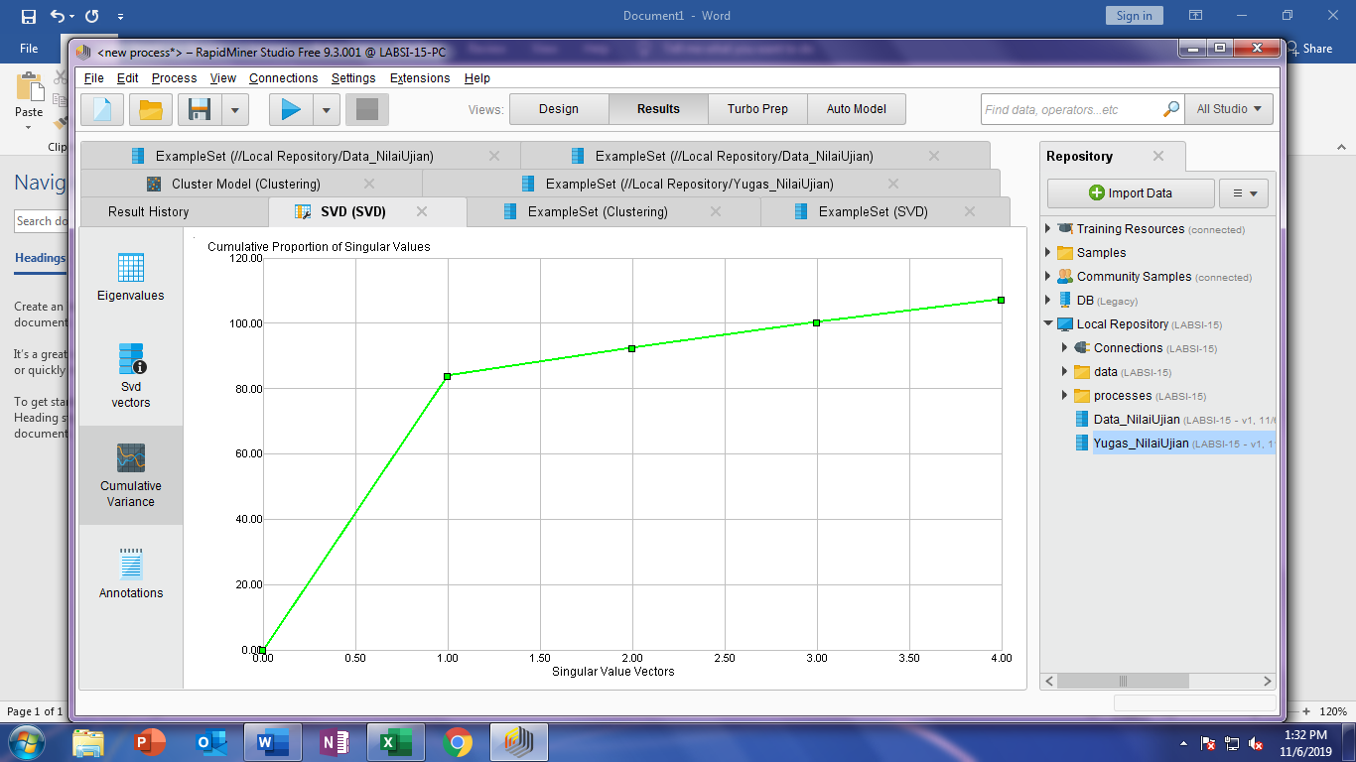

1. Example Set k-Means

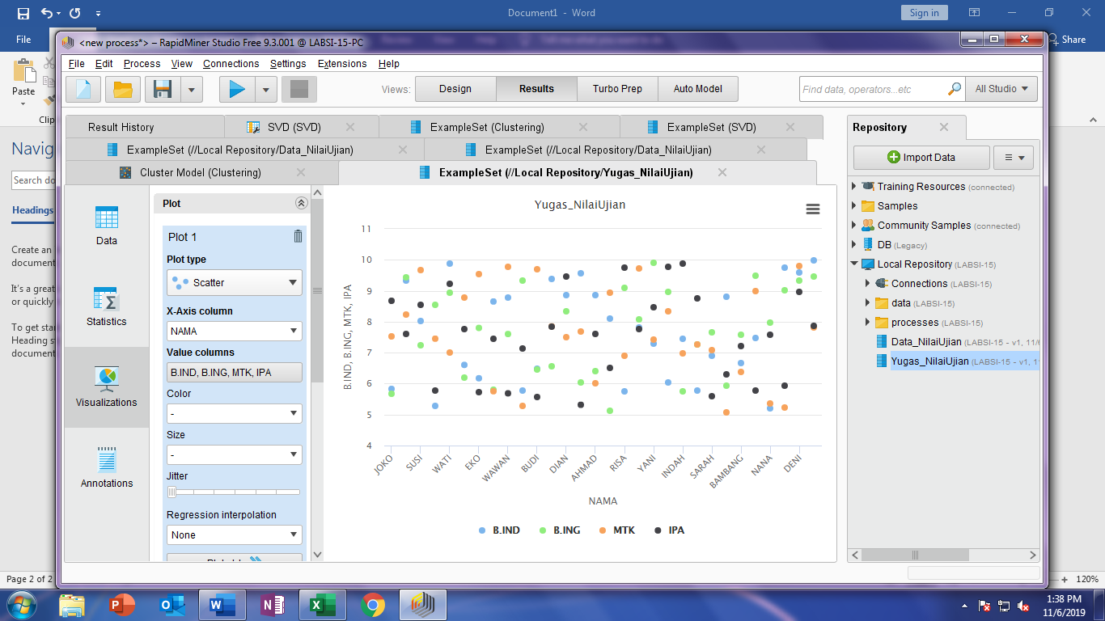

1. Example set svd

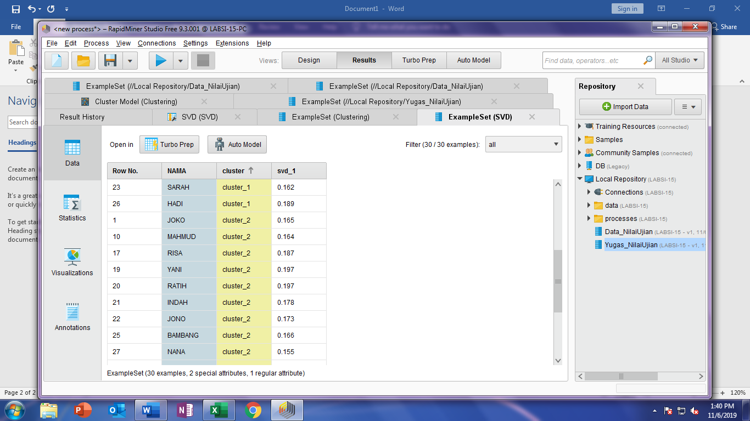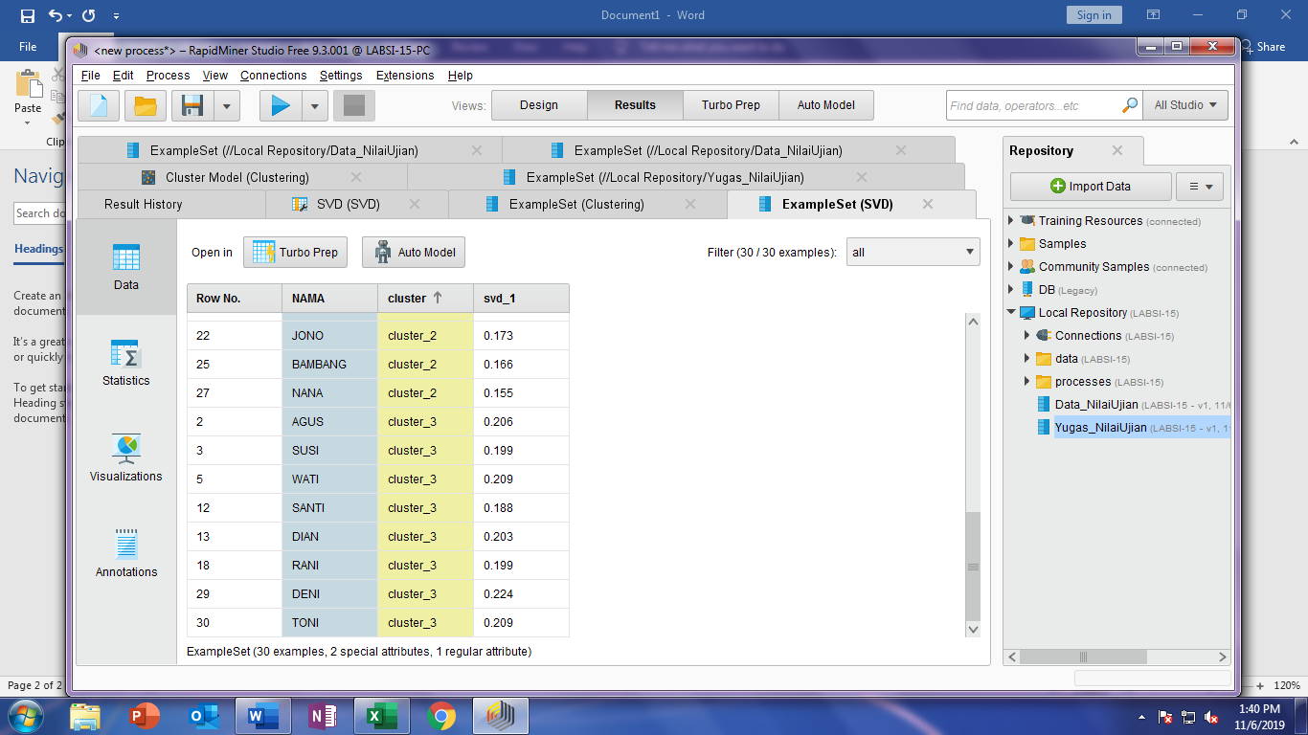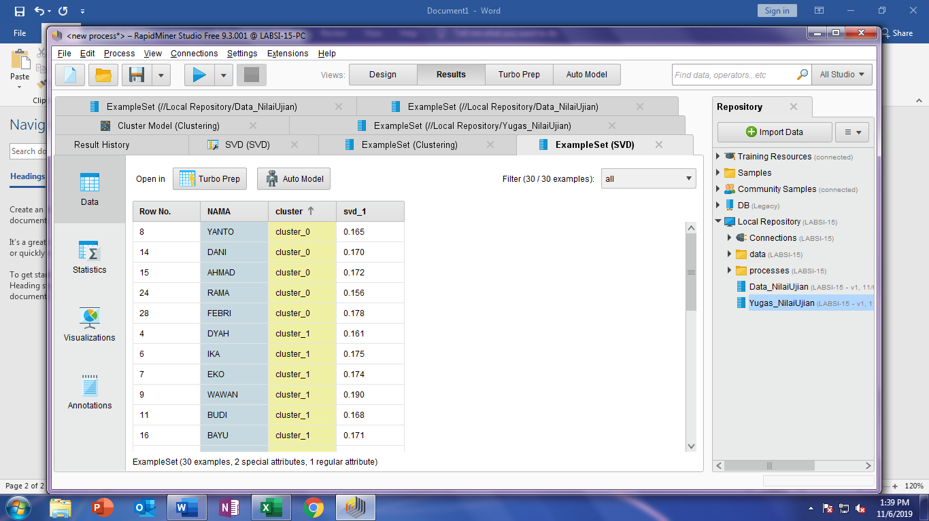

1. Cluster Model
2. Description

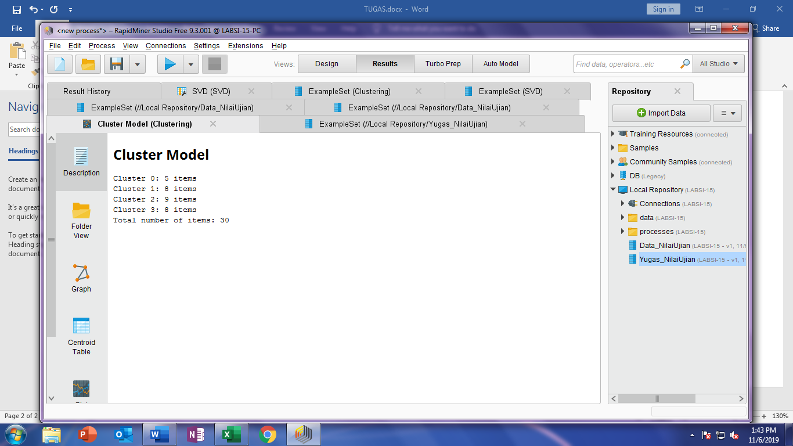

1. Graph

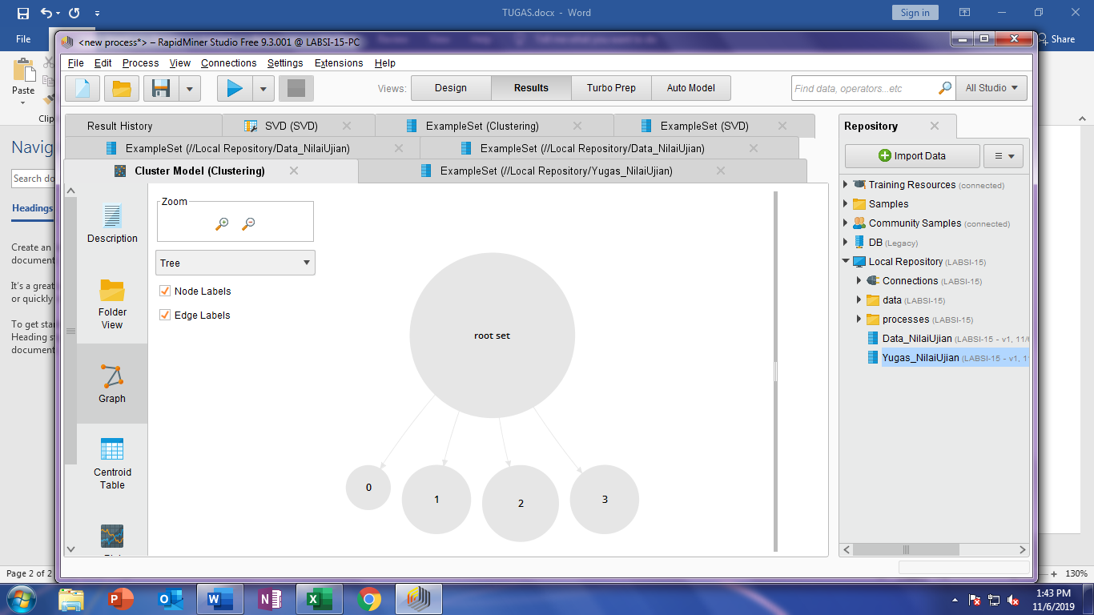

3. nama siswa di cluster 0, 1, 2, 3

